**Metadata 101: Using Attributes in Creo Illustrate**

**Intro**

For years, service procedures have been distributed through service manuals. In the more recent term, service procedures have been able to be turned into instructional videos. These methods, however, are both 2D representations of a 3D object. Using AR, work instructions for 3D object can be created in 3D by overlaying data on top of a physical model or on a separate digital representation of that model. Before these instructions are viewed in AR, they are created by an engineer on a computer. The animations for these work instructions are saved in the metadata of a CAD model, which will be defined in the coming project. This allows engineers to do work quicker and more efficiently than reading a manual, be safer when performing the procedures, and reduce having to rework incorrect procedures.

Metadata is a generic term used to describe underlying data that provides information about a certain item’s content. Metadata can come in many different forms and have different names. In the case of Creo and Windchill, metadata is stored a model’s **attributes**. These attributes hold data that is unique to each component of the CAD model in an organized and ready to use way. The data in the attributes of a model can be used when calling upon a part in operations using Vuforia and ThingWorx. Examples of attributes are **sBOM ID Path**, which explains the location of a part/assembly in the model tree structure, and **source file name**, which shows the exact name of the file of the part that is being queried. Attributes can be automatically created during modeling in Creo, like the ones listed before, but attributes can also be added to a model manually. This tutorial will explain how to manually add attributes, like individual **part numbers**, that will correspond to a part number and a sequence number that will be used when creating an experience in Vuforia Studio.

Concepts covered in this section will be creating a phantom view of a model, creating an animated sequence, and adding attributes to a model.

This tutorial is based off users creating this data from a blank illustration file. Completed Creo Illustrate files named **quadcopter101.c3di** and **quadcopter.pvz** will be provided as a point of reference.

**101.1 Load the Model into Creo Illustrate**

Before any actions can be made with the quadcopter model, it needs to be loaded into Creo Illustrate.

1. Open Creo Illustrate.

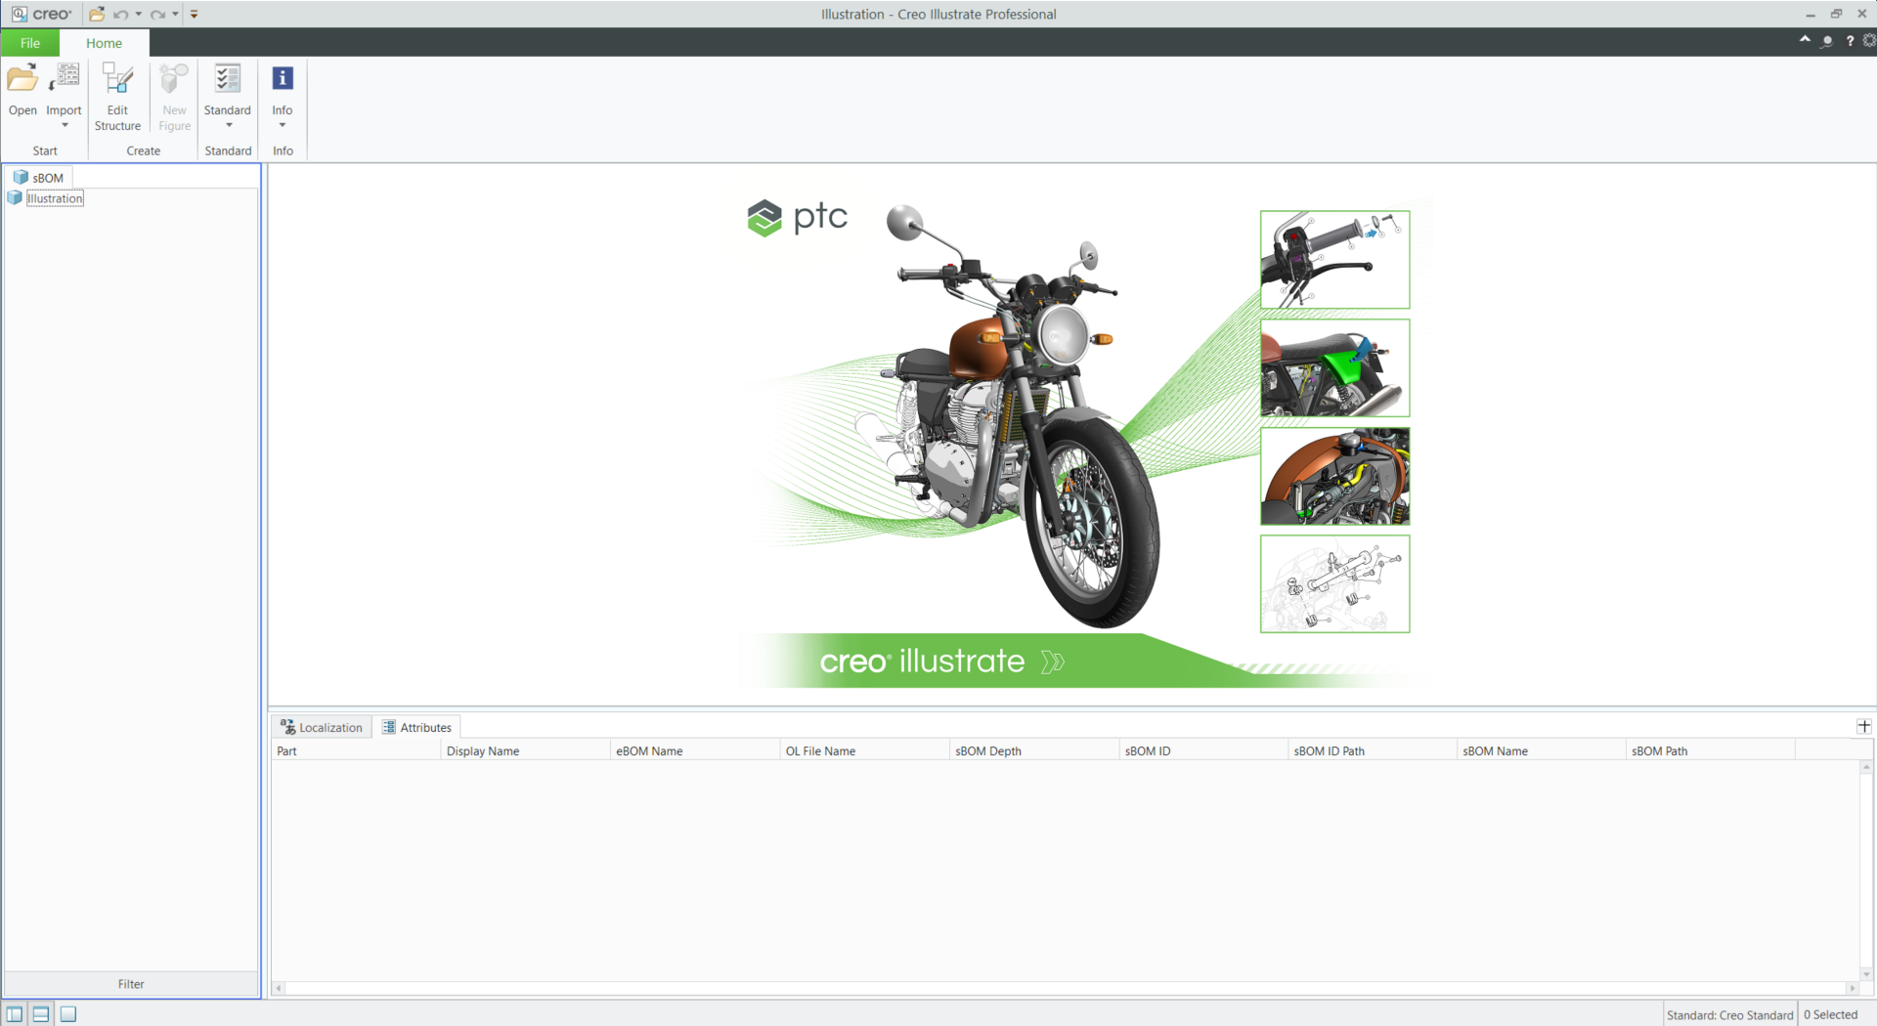

1. Click **Link** in the **Import** dropdown menu to link the file to an existing CAD model. Linking the model ensures that all updates to the source model are reflected inside Creo Illustrate as well.

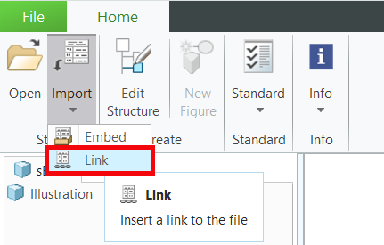

1. Select the **quadcopter_start.pvz** file that was downloaded with this project from its download location.
2. Select **Update after confirmation only, then** click **OK**. The model will not be updated outside of Creo Illustrate for this activity.

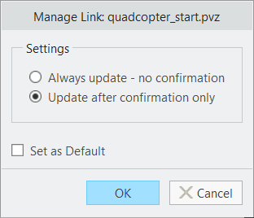

1. To get the model to appear in the **New Figure** window, click **Default** and ensure that the **Preview** checkbox is selected. Once the model appears, click **Create**.

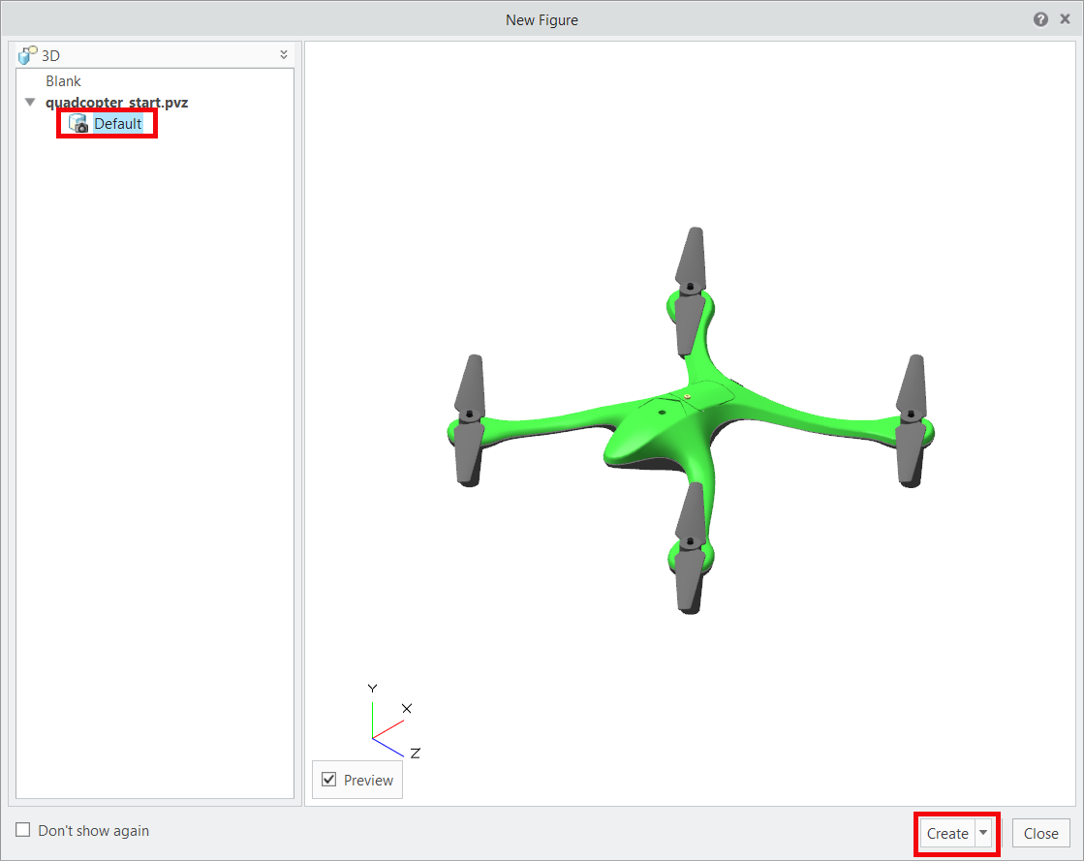

1. Move the **New Figure** window to the side. If the model appears in the graphics window of Creo Illustrate behind the **New Figure** window, then it has been imported successfully. Click **Close** on the **New Figure** window.

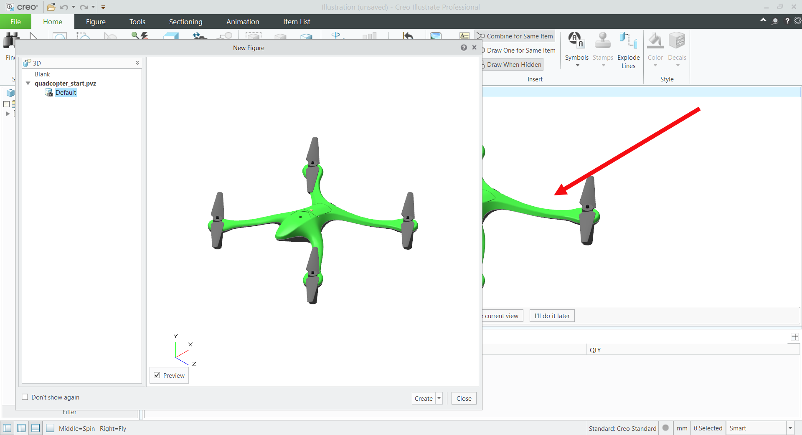

1. The model is now ready to be edited.

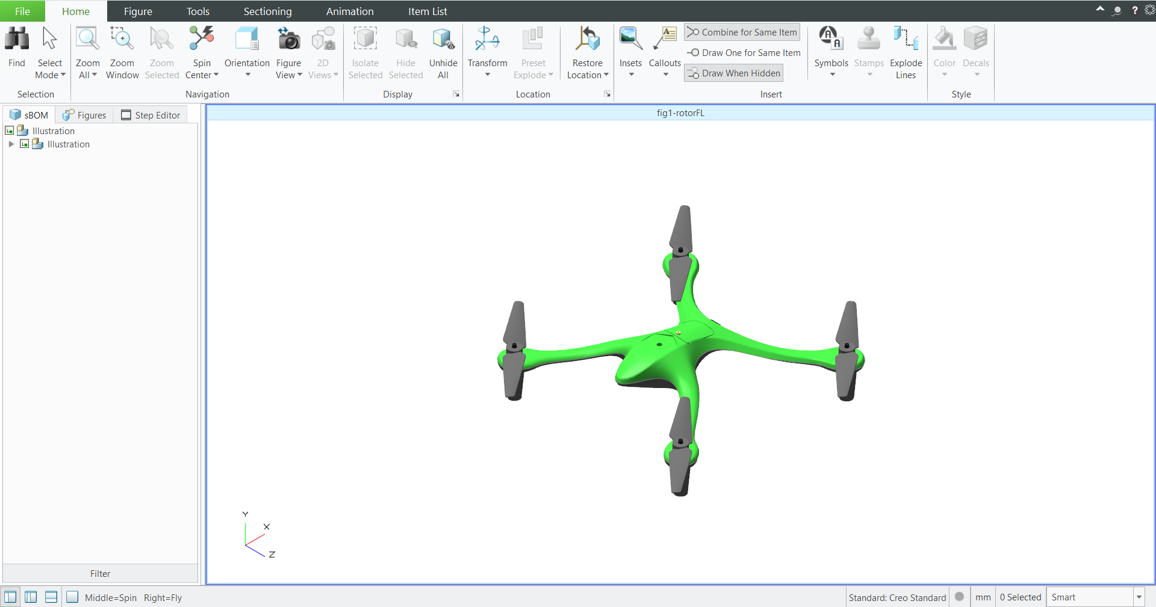

**101.2 Add Attributes**

Attributes allow you to access different types of metadata that is associated with a model. In this case, attributes are being added that will be accessed inside Vuforia Studio in a later part of the project. This section shows you how to add those attributes to a model and prepare the model for the next section of this activity. The attributes being added are part numbers for part recognition in the AR experience, and sequence identifiers to differentiate between sequences. These sequences will be performed on the different sections of the quadcopter.

1. If not already visible, open the **Lower Data Panel** to reveal the **Attributes** tab.

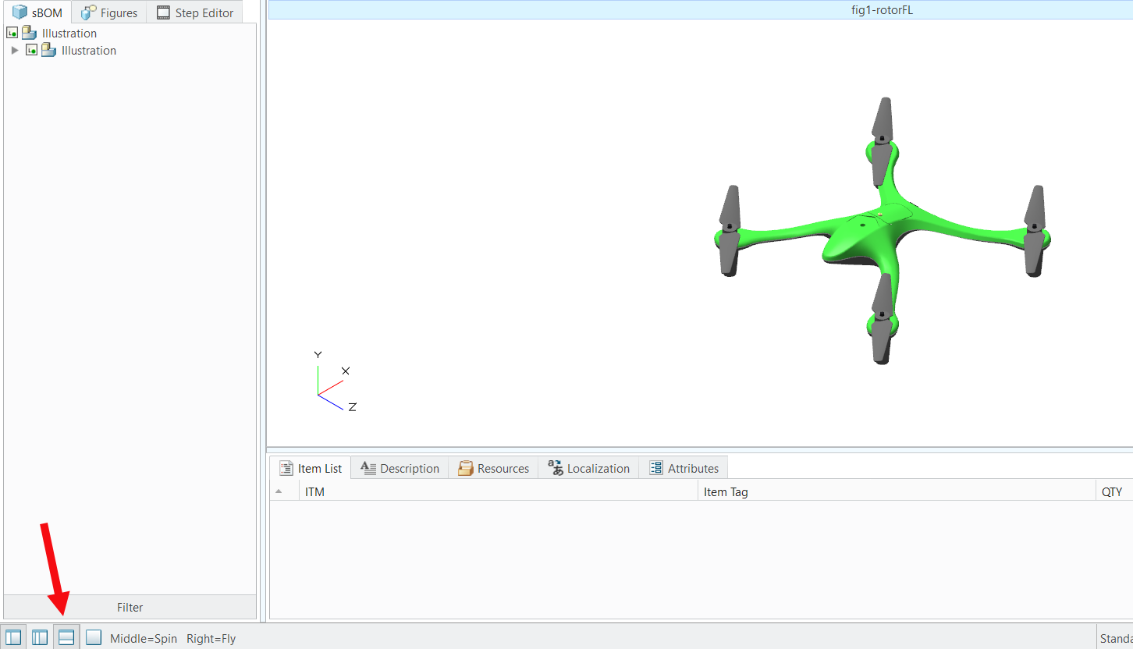

1. From the **Tools** tab, select **Edit Structure.**

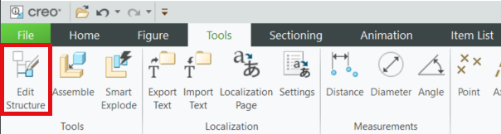

1. Click **OK** on the **Edit Structure** pop-up since the intent is to edit the **sBOM** structure and animations haven’t been created yet.

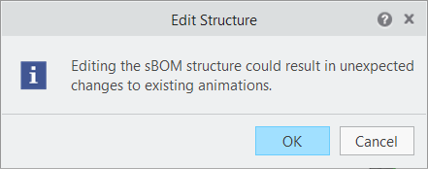

1. The model will not be visible at first. Select the checkbox next to the name of the model to make the model visible. Once the model becomes visible, it is blue. This is expected and not an error.

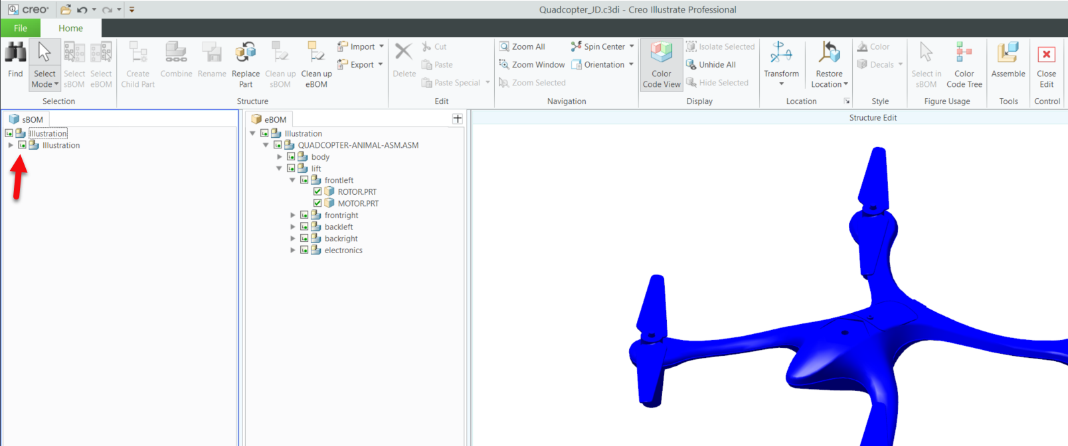

1. Use your mouse to drag a box around the assembly in the graphics window to select all parts on the quadcopter. You will notice that the parts are highlighted in the **eBOM** tab in the **Upper Data Panel** but not in the **sBOM** tab in the **Primary Data Panel.** There is a difference between the two tabs; the **eBOM** is the engineering bill of materials that is imported with the CAD model for the quadcopter, while the **sBOM** is the service bill of materials, which is specific to the instance that is being worked on in Creo Illustrate and displays the attributes of the model.

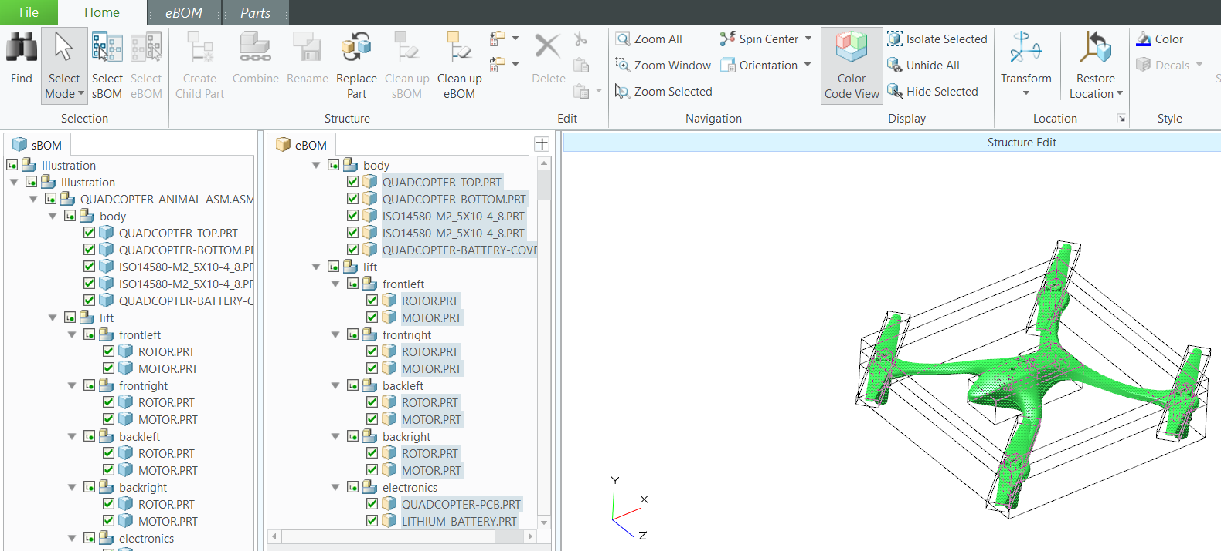

1. In the ribbon, click **Home** and then **Select sBOM** to switch to the **sBOM** tab. This highlights the parts in the sBOM instead of in the eBOM, which allows for editing.

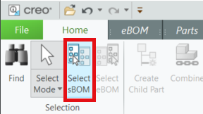

1. With all parts highlighted in the **sBOM** tab, open the sBOM tab in the ribbon, and select **Edit Properties**.

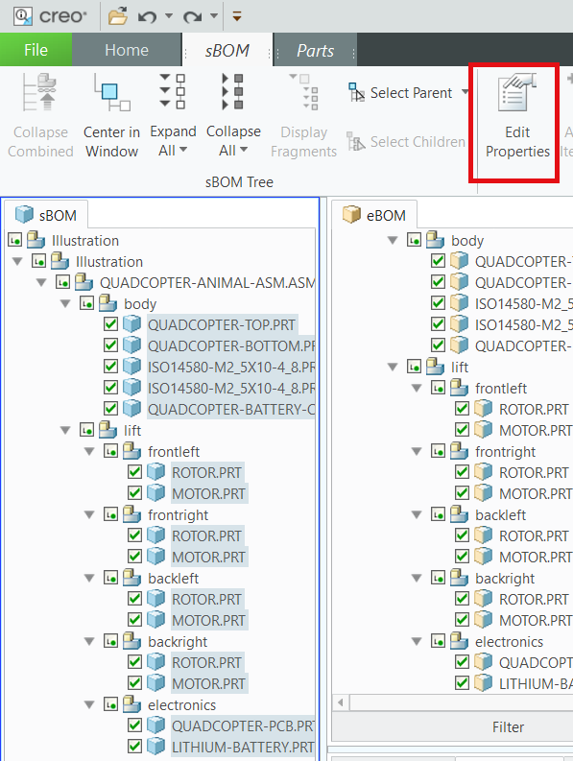

***Troubleshooting note****: When you first select all parts of the model by dragging a box around it, you may find that after clicking* ***Select sBOM****, there is only a tab labeled* ***eBOM*** *and there is no*  ***Edit Properties*** *button. To resolve this issue, deselect all parts, and then select each part in the* ***sBOM*** *individually.*

1. In the **Part Properties** window, click **Attributes.**

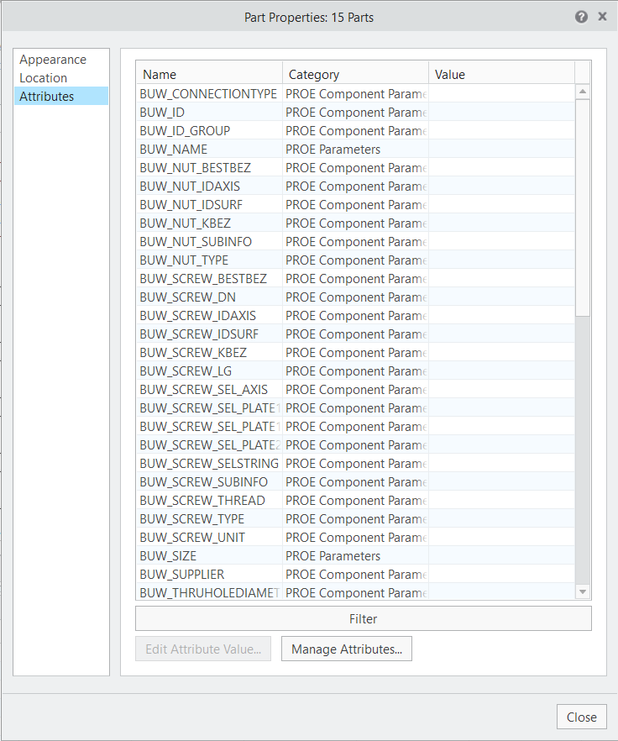

1. Select **Manage Attributes…** at the bottom of the window. The Attribute Manager opens.

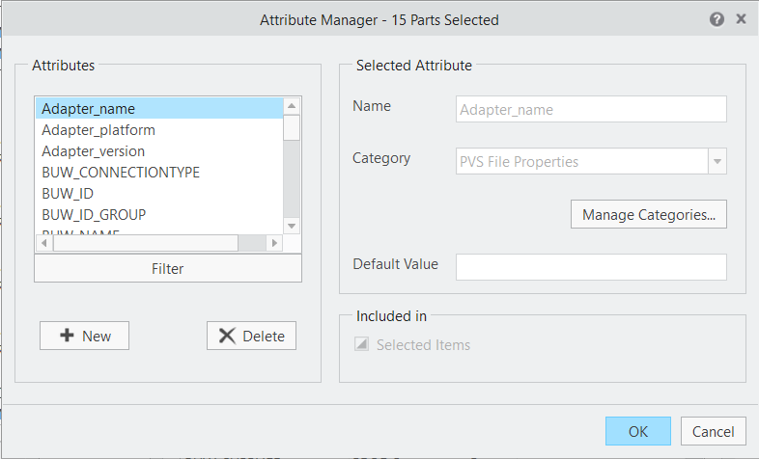

1. Click **New** to open the **Add New** Attribute window.

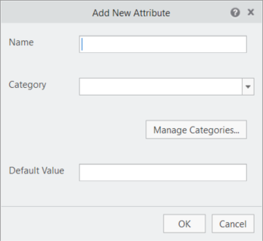

1. Enter “partNumber” in the **Name** field.
   1. Part numbers are important in the manufacturing process, as they help differentiate between parts. In terms of attributes in Illustrate, each part in the sBOM is an individual instance of a part, but the same part can be used more than once . Each instance of a part will have a unique Feature ID, but the part number will be the same for the parts. **ROTOR.PRT** will always have a **partNumber** attribute of Rotor-1234, but the Feature_Id attribute will vary for each instance that it is placed in the model. If a different rotor were to be placed in the model, then it could have a part number of Rotor-6789, which would differentiate between the different rotors.
2. Select **PVS File Properties** from the **Category** dropdown.
3. Leave the **Default Value** field blank. This field would be filled in if there was a portion of an attribute that would be shared between all parts. For example, if adding a country code for international phone numbers, a + could be added as a default value, because for each extension, no matter what the part is, the phone number for ordering the part is going to start with “+.”
4. Click **OK.**

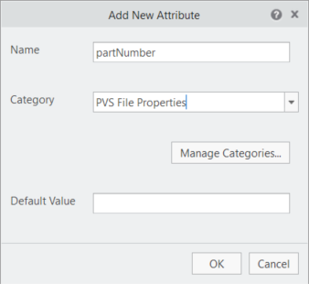

1. The **Attribute Manager** appears again. Click the **Selected Items** check box until it has a check in it. This will add the property to all parts in the sBOM. The other options for the check box are for including only currently selected items or not including in any of the items.

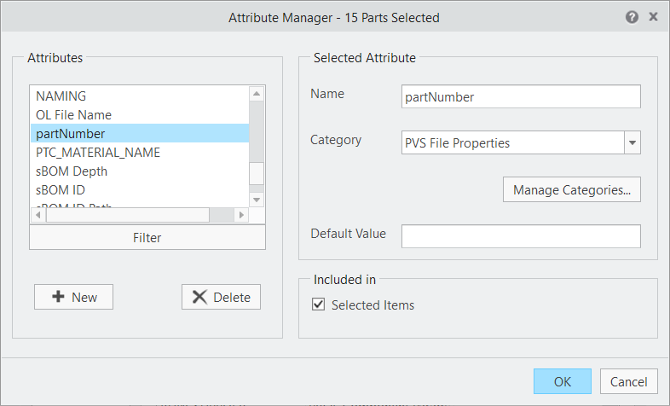

1. Create another attribute and name it **Illustration.** For **Category**, select **PVS File Properties** as the **Category**, and leave **Default Value** blank. This new attribute is what contains the property that ties a figure to an illustration sequence. Include this for all items as well. When finished, click **OK** and close the **Attribute Manager**.
2. Close the **Part Properties** window to return to the graphics window.
3. If the new attributes were created successfully, the new properties for **partNumber** and **Illustration** will appear at the top of the **Attributes** list when a part is selected in the **sBOM**. If they are not appearing at the top of the list, go back and ensure that when the parts were selected that the attribute was included for all parts.

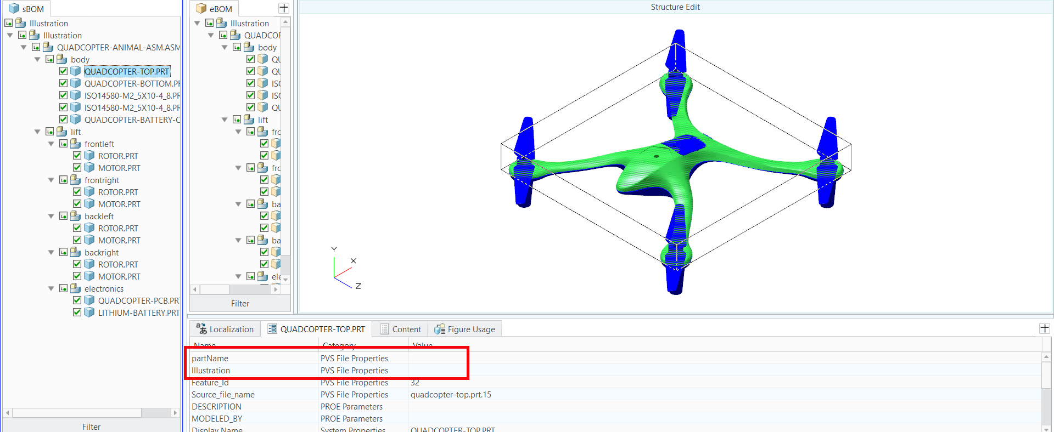

1. Attributes can be edited while the **Attributes** tab is open in **Edit Structure** mode. When a part is selected, the header of the tab will change from **Attributes** to the name of the selected part. Double-click on an attribute to open the **Attribute Detail** window that will display the **Category**, **Name**, and **Value** of the attribute.
   1. Select **ROTOR.PRT** in the **frontleft** assembly in the **sBOM** tab.

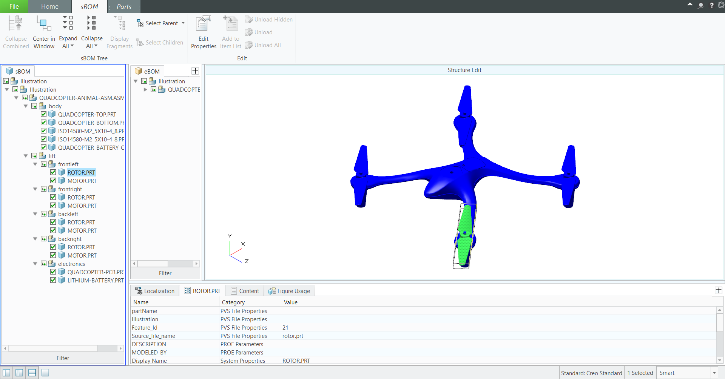

* 1. Double click the **partNumber** attribute in the **Attributes** tab, which has now changed its header to **ROTOR.PRT** to reflect the selected part. This will open the **Attribute Detail** window.
  2. Add a value of **Rotor-1234** into the **Value** box.

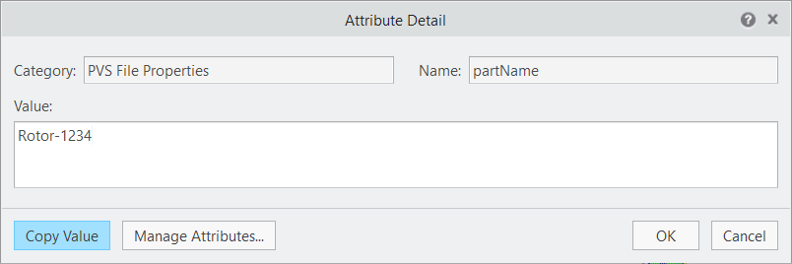

* 1. For the same part under the **Illustration** attribute, add a value of **fig1-rotorFL**. These attributes will be used in the accompanying Vuforia Studio experience.

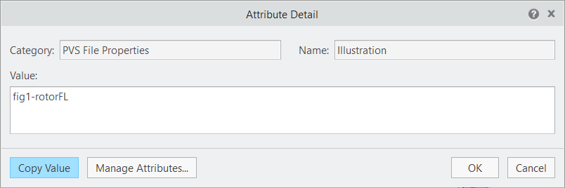

* 1. For the **MOTOR.PRT** part in the same assembly, add a value of **Motor-5678** for the **partNumber** and **fig1-rotorFL** for **Illustration**. In this case, a different part is being used, but since it is part of the same illustration sequence, it will share a similar property with **ROTOR.PRT**

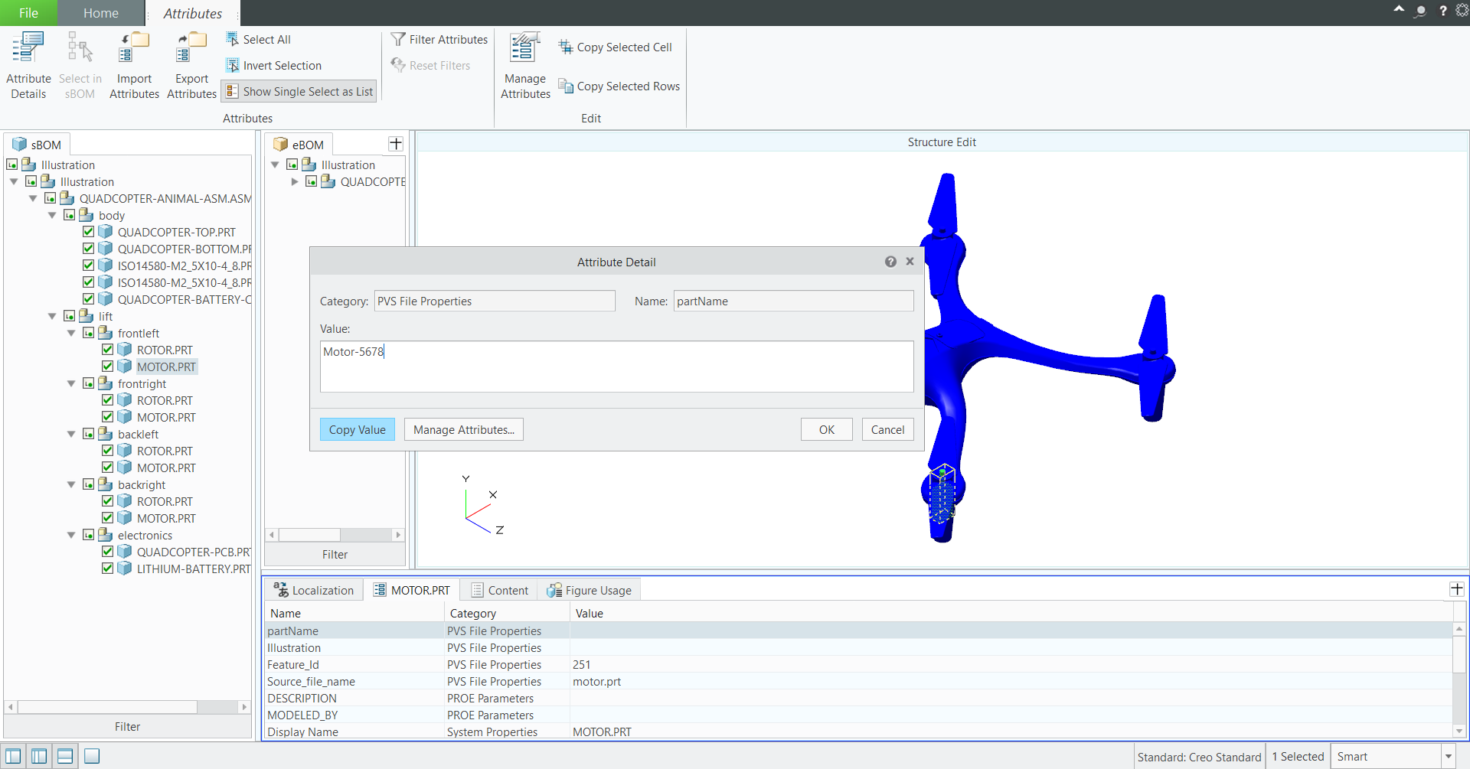

* 1. If there were another figure created to illustrate the front right rotor being taken off , the **ROTOR.PRT** part in the **frontright** assembly would have a **partNumber** of **Rotor-1234**, just like the other rotor since they are the same CAD part, but would have an **Illustration** attribute of **fig2-rotorFR** since it is part of a different sequence.

1. After adding the attributes, the Attributes tab should look like the one below:

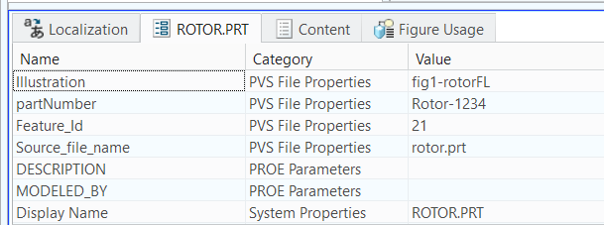

1. Your new attributes have now been added to a part! Continue this process for each of the parts in the model listed in **Appendix 1** below. If a part is not part of an animation in the design, then it will not have a value for the **Illustration** property.
2. To close out of the **Edit Structure** interface, go to the **Home** tab in the ribbon and select **Close Edit** on the right end of the ribbon
3. Open the **File** tab and click **Save**. Save the file as **quadcopter**. This will create a .c3di file, which is the file format for Creo Illustrate. This file will be later exported as a .pvz file, which is a format that can be read by Vuforia Studio. A completed .c3di file called **quadcopter101.c3di** will also be provided with all attributes filled in.

**101.3 Add a Phantom View to the Model**

Adding a phantom view to a part can be thought of as the opposite of highlighting a part. Phantom views are used when a certain part needs to be clearly visible within the context of an assembly. Phantom views can be added at any step in an Illustrate sequence and are commonly found in AR experiences for startup and repair procedures. Use the following steps to learn how to add a phantom view to most of the quadcopter and show only the essential parts for a repair procedure. These effects are added to edit the appearance of the model before the repair sequence starts.

When completed, the .pvzfile from Creo Illustrate will include a phantom view and dissembly sequence (created in the next section). When the .pvz file is uploaded into Studio, the result will look like the images below. The first image is of the first step of the sequence; all the parts are at the same color saturation level. The second image shows the second step where all parts with a phantom effect are visibly toned down. In the second step, the front right motor and rotor are highlighted as a repair sequence is starting.

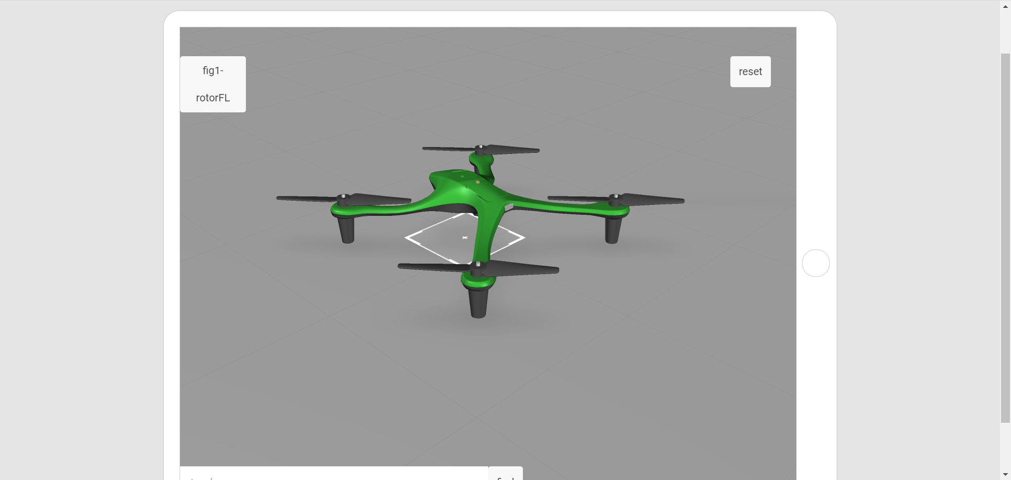

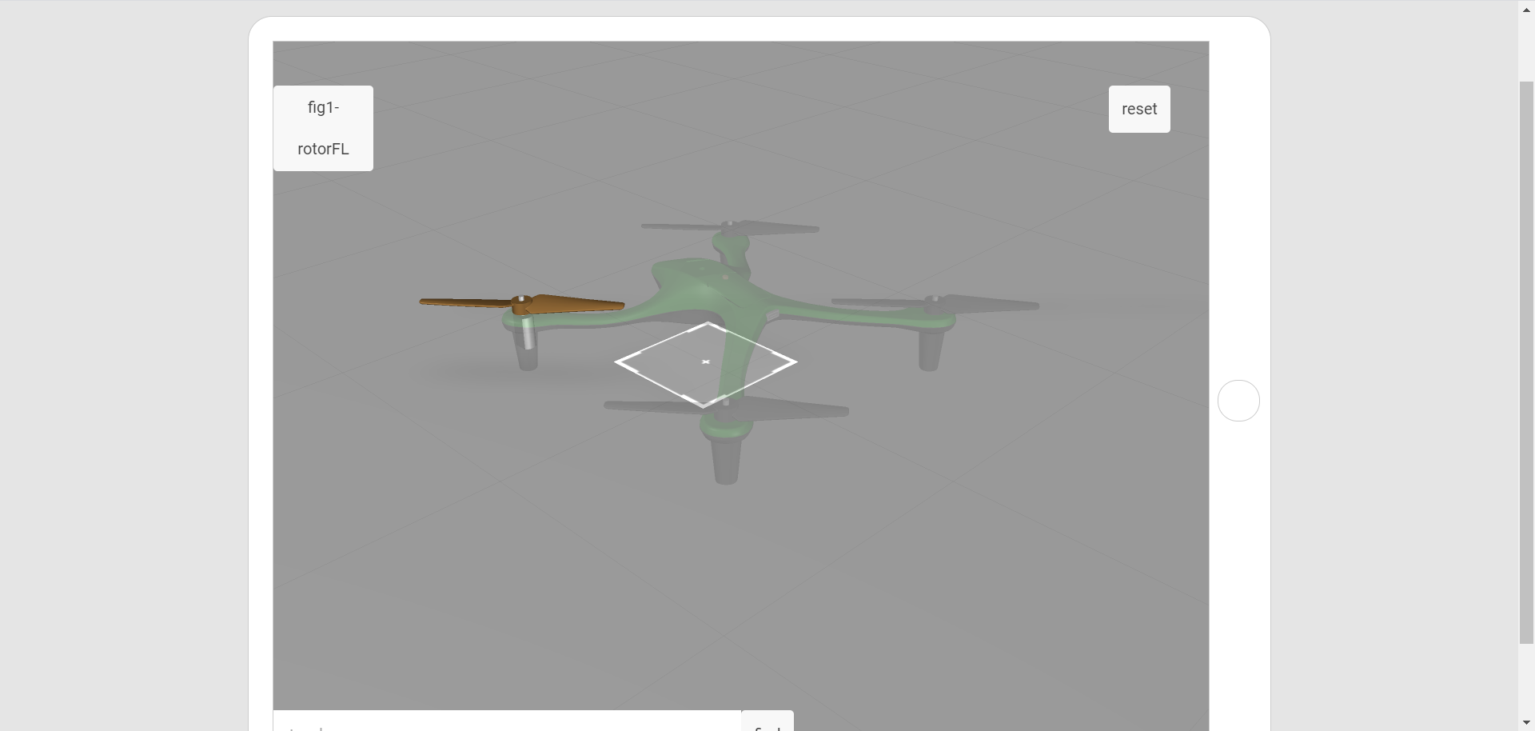

1. The **ROTOR** and **MOTOR** parts in the **frontleft** subassembly in the **lift** subassembly are the intended visible parts. All other parts will be phantom.
2. Right-click inside the **sBOM** tab in the **Primary Panel**. Select **Expand** and then **All**. This will expand the model tree to show all parts of the model.

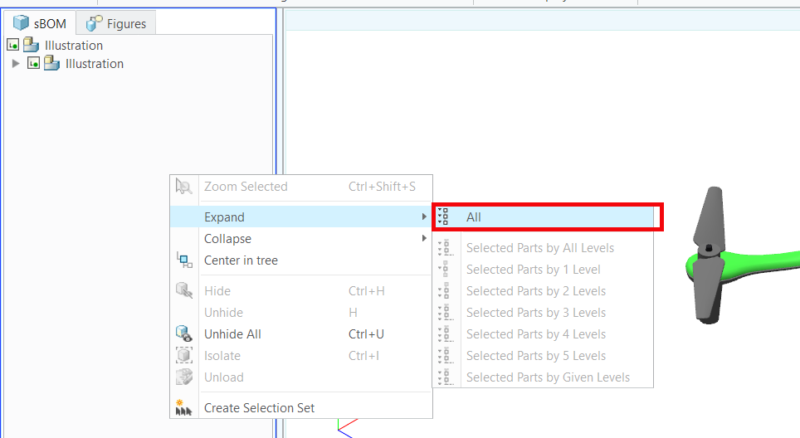

1. In the **sBOM** tab, select all parts other than the rotor and motor in the **frontleft** assembly so that the model looks like the image below.

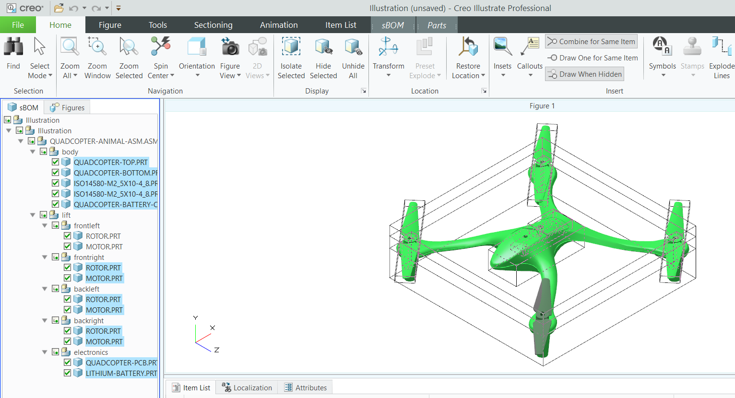

1. With the parts still selected, navigate to the **Parts** tab in the ribbon and select **Edit Figure Phantom** within the **Style** section of the tab. This adds the phantom effect to the selected parts.

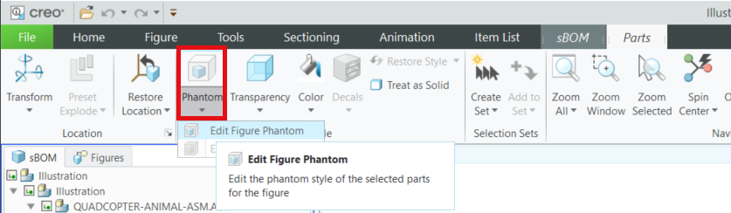

1. If the phantom view was added successfully, the model should now look like the image below. Notice that the color of the front left rotor and motor did not change, but the color of the parts that are meant to be toned down did.

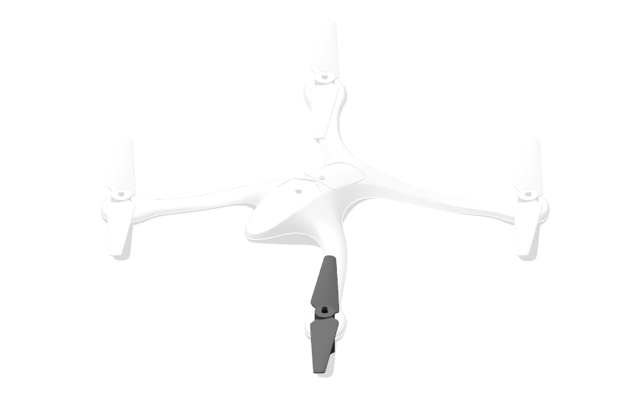

**101.4 Create a Disassembly Sequence using Creo Illustrate**

Industrial AR is often used for assembly/disassembly sequences, and these sequences are created within Creo Illustrate. Creo Illustrate allows you to create animations for CAD models with the help of their model structure. The tools featured in this next tutorial are Transform, Phantom, Flash, and Fly Out and will be used to remove the front left motor of the quadcopter. You can use the skills learned in this section to add animated sequences for the rest of the parts on the quadcopter.

1. Navigate to the **Figures** tab in the **Primary Panel**, hover over **Figure 1,** then right-click and select **Rename**. Rename the figure to **fig1-rotorFL**. Renaming the figure helps differentiate between multiple sequences.
2. To create a step-by-step animation for AR, a **sequence** needs to be added to the Creo Illustrate file. To add a **sequence**, navigate to the **Animation** tab and select **Sequence** in the **New** section in the ribbon.

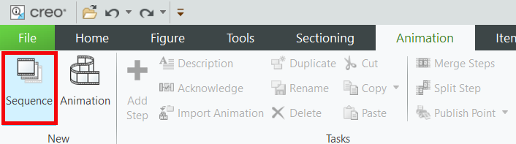

1. The **Step Editor** appears in the Primary Panel with an initial structure that looks like the image below. Each step in the sequence features a separate animation. When these steps are played at the same time, they create a comprehensive sequence for disassembling the motor from the rest of the quadcopter.

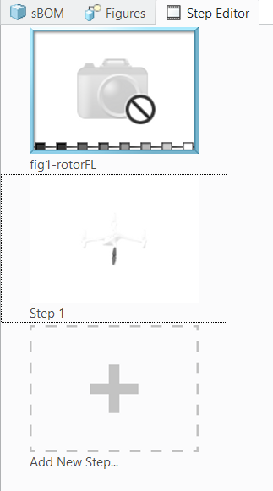

1. Before starting a sequence, ensure that the **Record Content** button is selected in the **Animation** tab. The red circle in the corner of the screen signifies that this feature is active, and that all changes that are made to the model during the step are being recorded. If **Record Content** is not selected, the changes will not be recorded for playback.

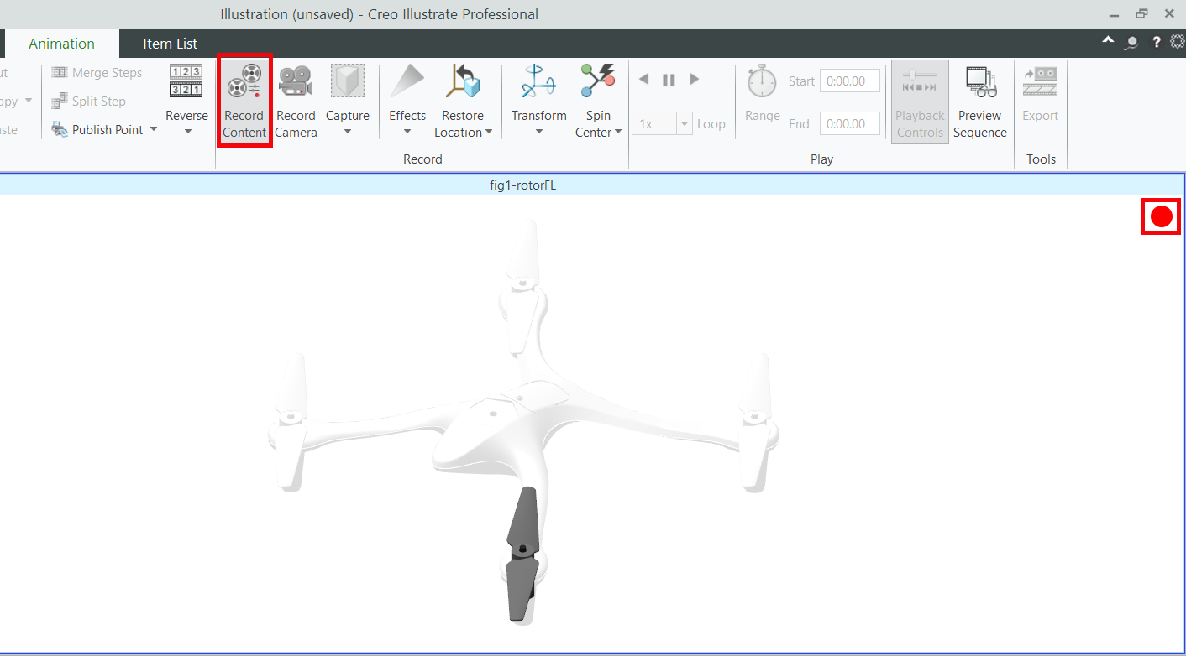

1. **Step 1: Remove the motor**
   1. Click **Step 1** in the **Step Editor** to begin editing the step. The Lower Data Panel, consisting of the **Keyframe Editor, Item List, Description, Resources, Localization, and Attributes** tabs appears. This panel is used to edit the animated sequence of the model.

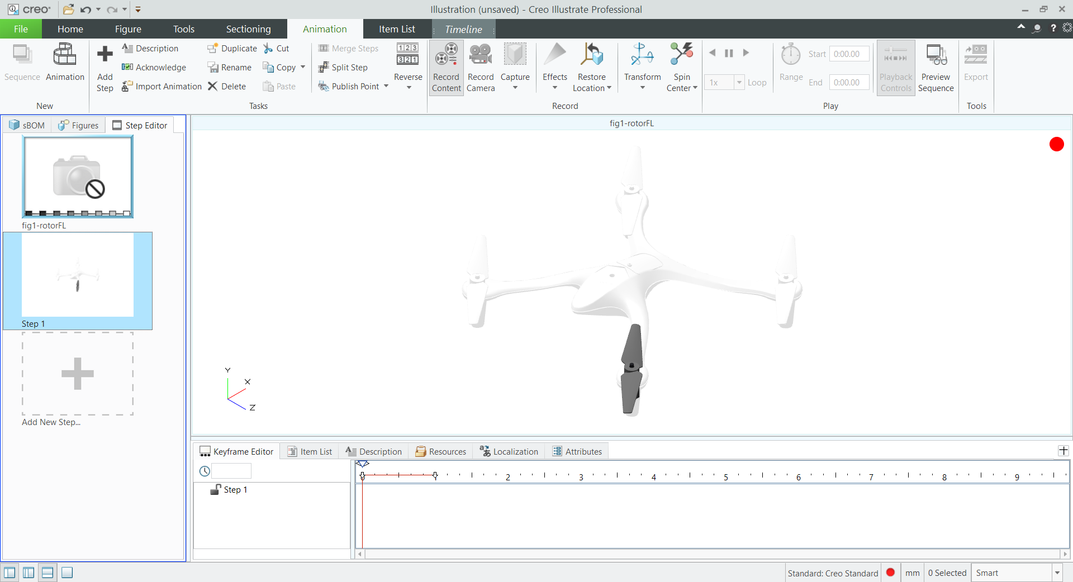

* 1. Select the visible rotor and open the **Effects** dropdown in the **Animation** tab. Choose the **Flash** effect and select a color.  
     ***Troubleshooting Note:*** *If* ***Flash*** *is not available as an option in* ***Effects****, make sure that* ***Step 1*** *is selected in the* ***Step Editor****. If* ***fig1-rotorFL*** *is the selected frame, the* ***Flash*** *effect will not be available.*

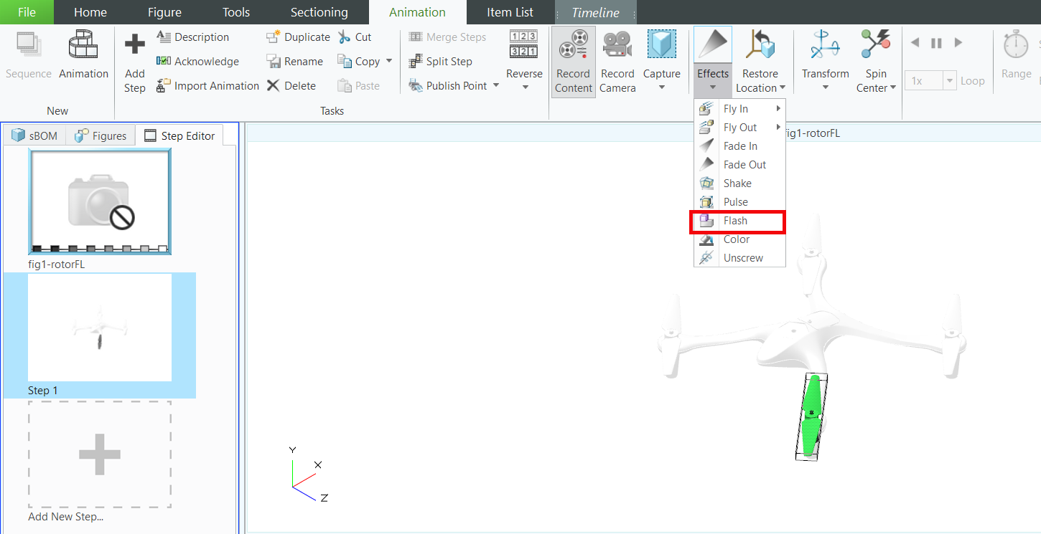

* 1. **Playback Controls** for the step appear. This gives you the ability to play the step in its current form and move around to a certain point in time.

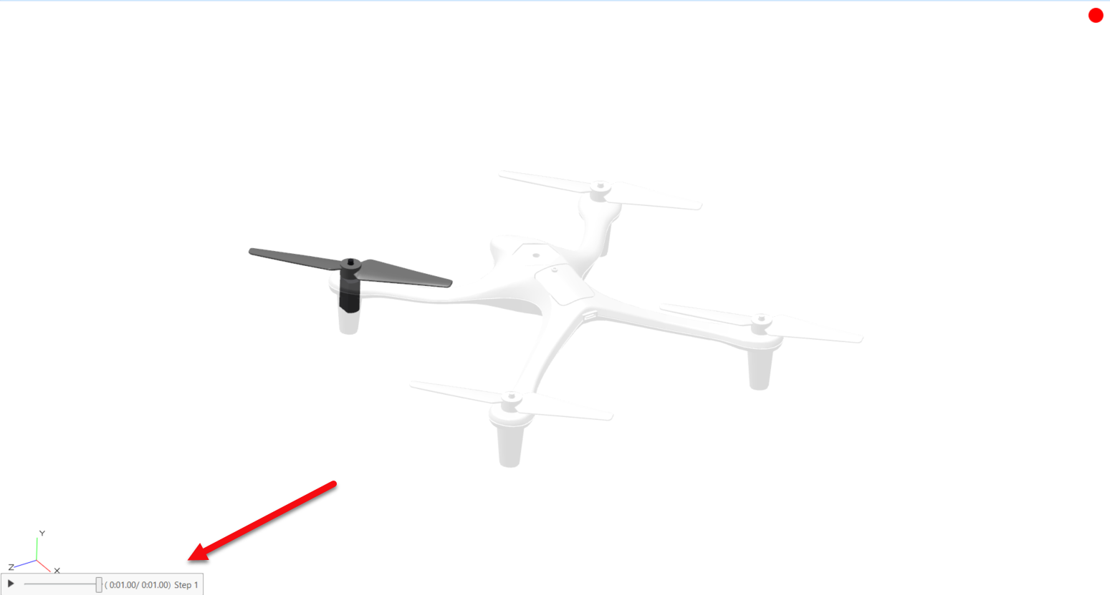

The **Keyframe Editor** provides you with advanced controls for animations that allow you to edit the location, transparency, visibility, and color of a given part. It also allows for time editing of the step, which can be used for making a certain effect longer or shorter within the step, among other things.

* 1. With the same rotor selected, open the **Effects** dropdown again. This time, select the **Fly Out** effect. This effect causes the rotor to lift off the assembly and fade out. To make the rotor fly upwards, choose the **+Y** direction when prompted.

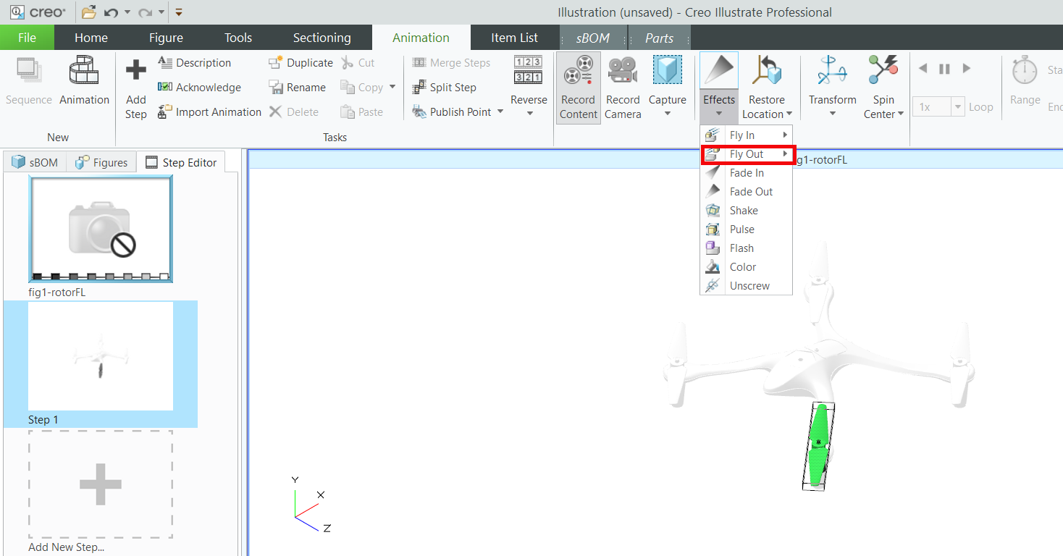

* 1. This completes the animation for **Step 1**. The model should currently look like this:

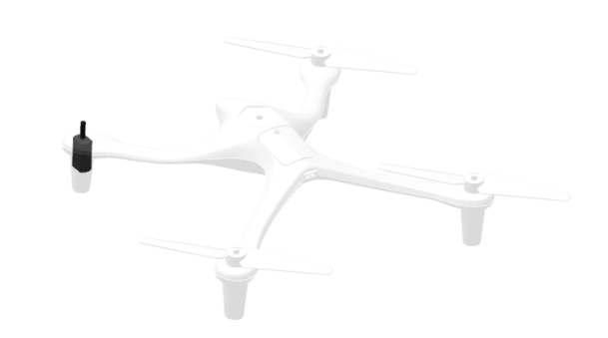

***Troubleshooting Note****: If desired, the playback controls can be moved back in time to edit incorrect portions of a sequence. For example, after* ***Step 1*** *has been completed, the step will be 2 seconds long. The 1st second will be for making the rotor flash and the 2nd second will be of the rotor lifting and fading out. If the fade out is incorrect, users can either hit the* ***Undo*** *button, or drag the playback control to 1 second into the step and just rerecord the action to overwrite the previously recorded motion.*

1. **Step 2: Remove the remaining** **rotors**
   1. Click **Add New Step** in the **Step Editor** to create a new step for the sequence. This will create a new frame called **Step 2** and will start where **Step 1** left off.

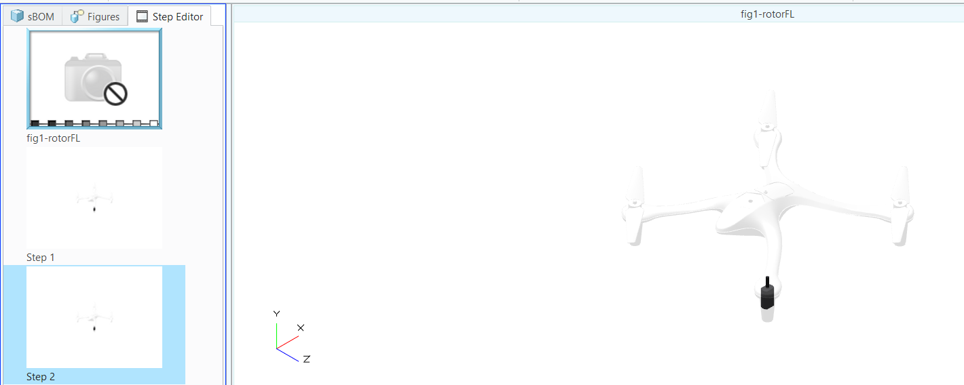

* 1. After removing the front left rotor, the three remaining rotors need to be removed. Even though they are in phantom view because this particular sequence is focusing on the front left motor, they still need to be removed in order to continue the process of taking the top of the quadcopter off and to reveal the motor. The rotors are going to flash before they are lifted, and in order to do that, they need to become visible again. Select the other three rotors by clicking them while holding down Ctrl + Alt. Holding the Alt key makes it possible to select parts that have been made phantom. In the **Parts** tab, click **Edit Figure Phantom** to turn off phantom for the rotors.

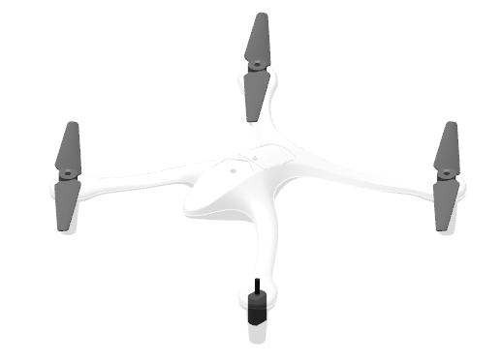

* 1. With the three rotors selected and visible, go navigate back to the **Effects** dropdown and select the **Flash** effect . Just like with the first rotor, use the **Fly Out** effect to make the other three rotors fly up and fade out .

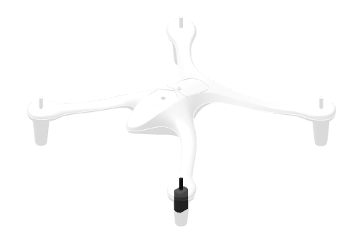

1. **Step 3: Take off the battery cover and quadcopter** **top**
   1. The last step that needs to be completed before the top of the quadcopter is taken off to reveal the motor is to take off the battery cover. Click **Add New Step**.

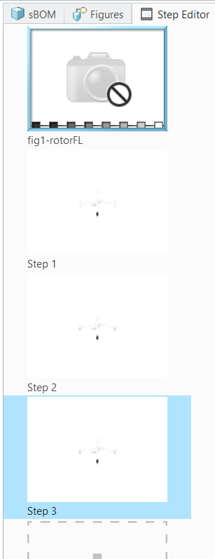

* 1. Since the screw for the battery cover is small and can easily be overlooked, it should be highlighted to show that it needs to be taken off. In the **sBOM** tab, select the screw named **ISO14580-M2_5X10-4_8.PRT** that is at the location shown (there are two instances of that part close together), and use **Edit Figure Phantom** to make it visible.

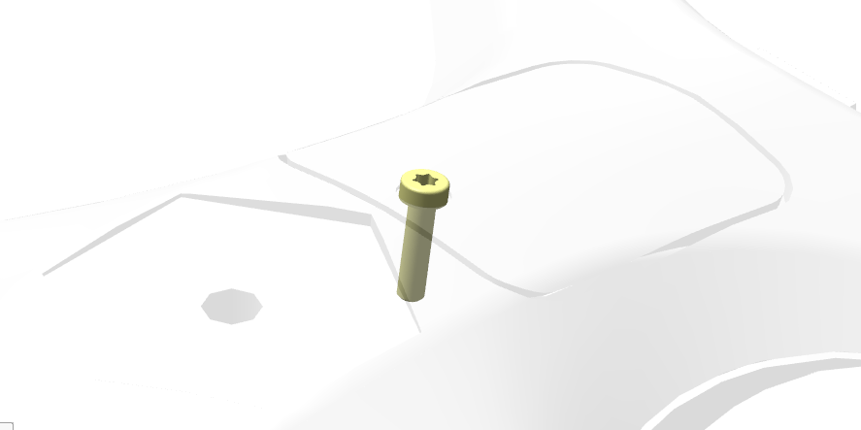

* 1. Use the **Flash** effect to flash the screw, and then use the **Fly Out** effect in the **+Y** direction to remove the screw.



* 1. Repeat the process of using the **Edit Figure Phantom** button to reveal the part, flashing using the **Flash** effect, and making the part fly away using the **Fly Out** effect in the **+Y** direction for the **QUADCOPTER-BATTERY-COVER** and **QUADCOPTER-TOP** parts.

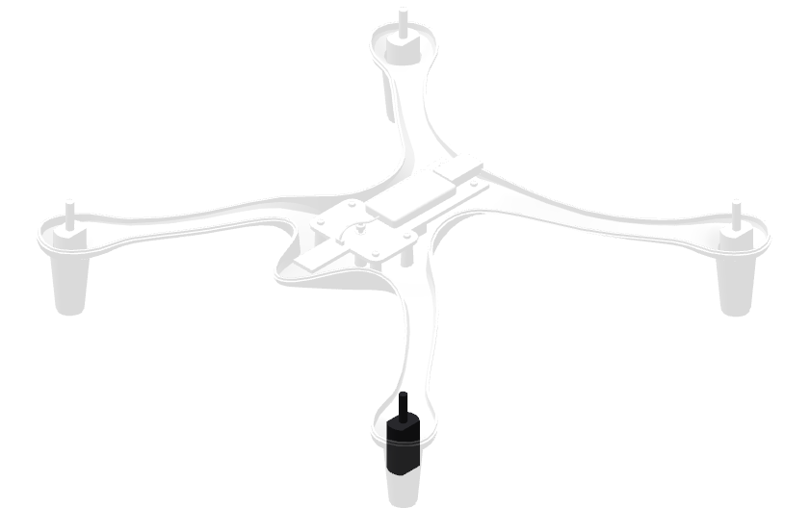

1. **Step 4: Remove the motor**
   1. Click **Add New Step**.
   2. Now that the front left motor has been exposed, it can be removed for inspection. Use the **Flash** effect on the motor.
   3. Use **Fly Out** to remove the motor. This completes the procedure for disassembling the quadcopter so that the motor can be accessed and removed.

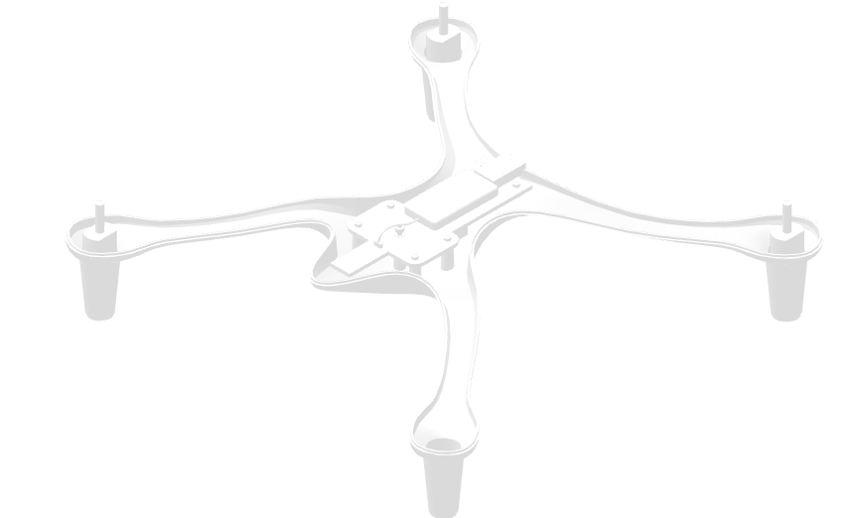

1. Taking what you’ve learned so far in this section, create 5 more disassembly sequences in the same .c3di file for:
   1. Removing the other 3 motors and rotors (front right, back left, back right) in the same way that the front left section was removed
   2. Removing the battery pack
   3. Removing the entire top section of the quadcopter

The completed **quadcopter101.c3di** file provided can be used as a reference for all the disassembly sequences.

1. Click the **File** tab and select **Publish**. Publishing a .c3di file allows it to be exported as a .pvz file. Save the published file as **quadcopter.pvz**. This file will be used in Vuforia Studio in the next part of this project.

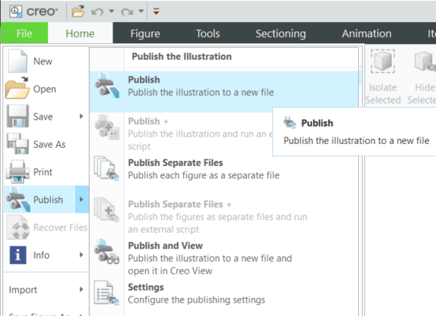

**Appendix 1: partNumber and Illustration Attribute table**

**Note:** (All sBOM depths are under the same path of Illustration > Illustration > QUADCOPTER-ANIMAL-ASM.ASM)

|  |  |  |  |  |
| --- | --- | --- | --- | --- |
| **sBOM Depth 4** | **sBOM Depth 5** | **sBOM Depth 6** | **partNumber** | **Illustration** |
| body |  |  |  |  |
|  | QUADCOPTER-TOP |  | qc-top-1111 |  |
|  | QUADCOPTER-BOTTOM |  | qc-base-1111 |  |
|  | ISO14580-M2_5X10-4_8 |  | bolt_4321 |  |
|  | ISO14580-M2_5X10-4_8 |  | bolt_4321 |  |
|  | QUADCOPTER-BATTERY-COVER |  | qc-cover-1111 | fig6-battery |
| lift |  |  |  |  |
|  | frontleft |  |  |  |
|  |  | ROTOR | rotor_1234 | fig1-rotorFL |
|  |  | MOTOR | motor_5678 | fig1-rotorFL |
|  | frontright |  |  |  |
|  |  | ROTOR | rotor_1234 | fig2-rotorFR |
|  |  | MOTOR | motor_5678 | fig2-rotorFR |
|  | backleft |  |  |  |
|  |  | ROTOR | rotor_1234 | fig3-rotorRL |
|  |  | MOTOR | motor_5678 | fig3-rotorRL |
|  | backright |  |  |  |
|  |  | ROTOR | rotor_1234 | fig4-rotorRR |
|  |  | MOTOR | motor_5678 | fig4-rotorRR |
|  | electronics |  |  |  |
|  |  | QUADCOPTER.PCB | pcb_1357 | fig5-all-lift |
|  |  | LITHIUM-BATTERY | battery_2468 | fig6-battery |